1. Application
   * Simple Frontend + Backend app
   * Use One Database (MySQL)
   * App must connect to the database successfully.
   * Host dynamic application and If I hit the Jump server IP, the application server should be accessible, and the database should be stored within the another vpc in different region.

-Step 1: Create VPCa

-Step2: Create 2 Subnet One should be Public and one should be Private

-step3: Create Internet Gateway and attach to VPCa to provide internet and associate public subnet .

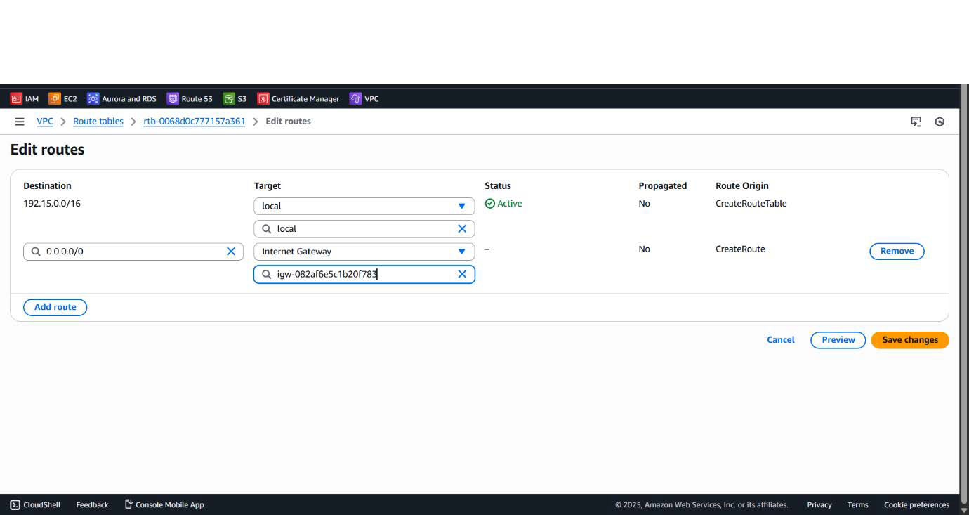

-step4: Create Route Table and route internet gateway in the route table and associate Public subnet into that route table.

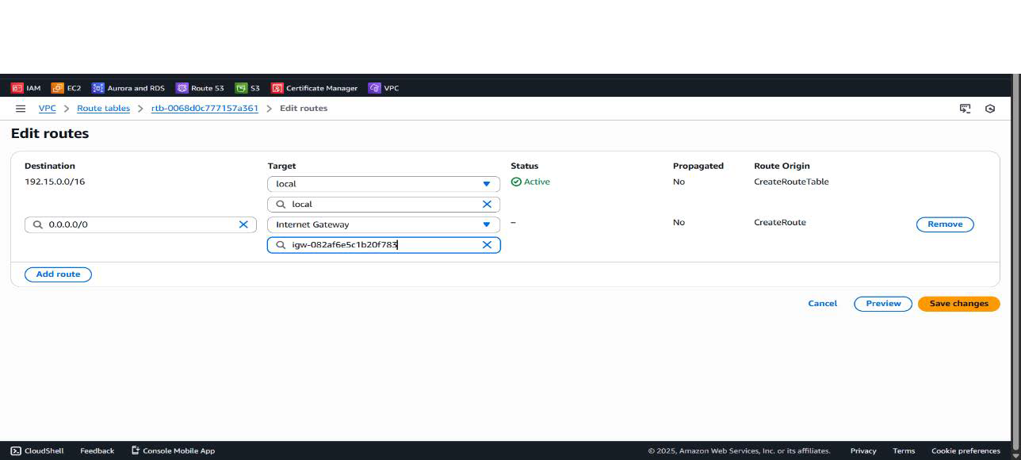

-step 5: Create ec2 instance/jump server in public subnet with auto assigned public ip should be enable. Create nat gateway to provide internet to the application server.

Create one route table and associate private subnet in the route table of the nat gateway .

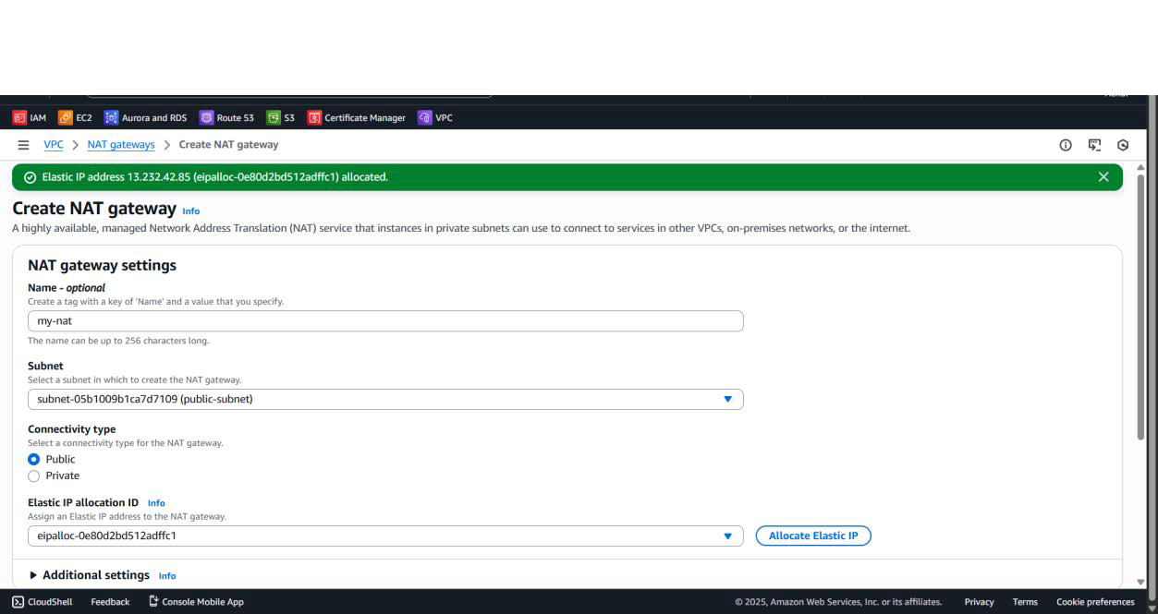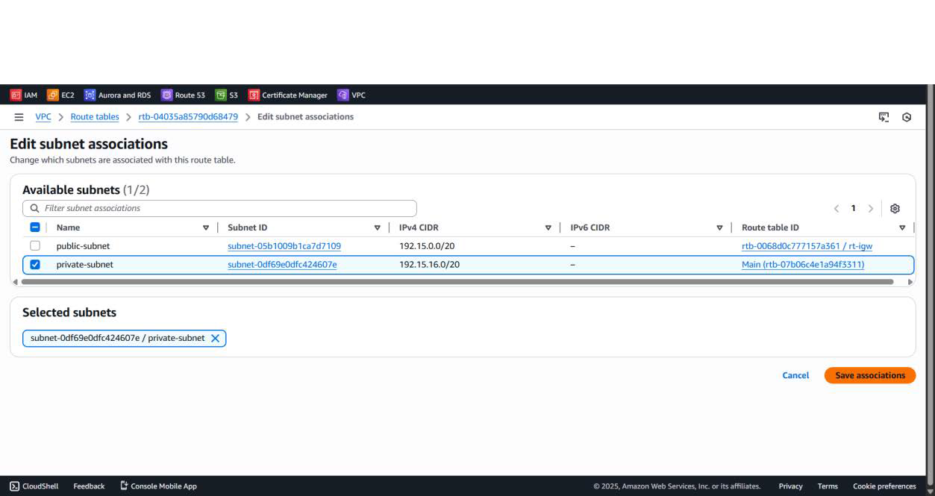

-step 6: Create ec2 instance /application server in private subnet with auto assigned public ip should be disable.

-step 7: Copy key from local machine to jump server to take access of the application server.

CMD – scp -i key-name(authentication) key-name(file) ec2-user@publicip:/home/ec2-user

-step8: Connect jump server on git bash terminal yum Install nginx

systemctl start nginx.service systemctl enable nginx.service

-step 9: Install tomcat on the application server from the google Curl -O <link of tomcat 9>

Then inside that tomcat folder bin folder will show enter inside bin folder and start Catalina.sh file then tomcat will start tomcatfolder/bin/

CMD - ./Catalina.sh start

-step 10: In the tomcat folder inside the webapp folder stored our

Application – student.war inside the webapp folder curl -O <https://s3-us-west-2.amazonaws.com/studentapi-cit/student.war>

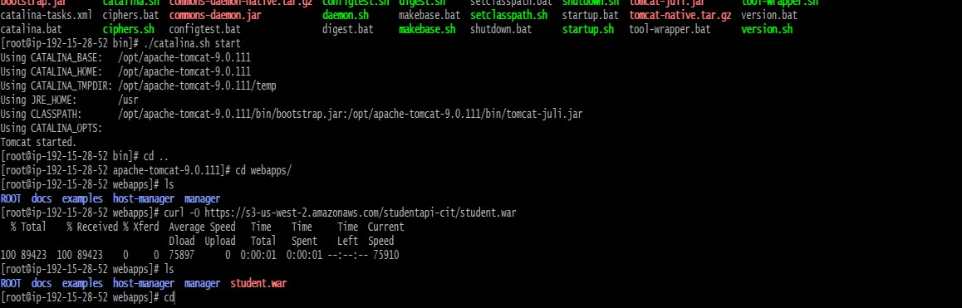

-step 11: Do some changes in the nginix.conf file for whenever we hit Public ip of jump server then request will go towords the Application server.

In the jump server vim etc/nginx/nginx.conf location / {

proxy_pass [http://privateIPoftomcat:8080/student/;](http://privateIPoftomcat:8080/student/%3B)

}

Do that changes in the configuration file of the nginx.

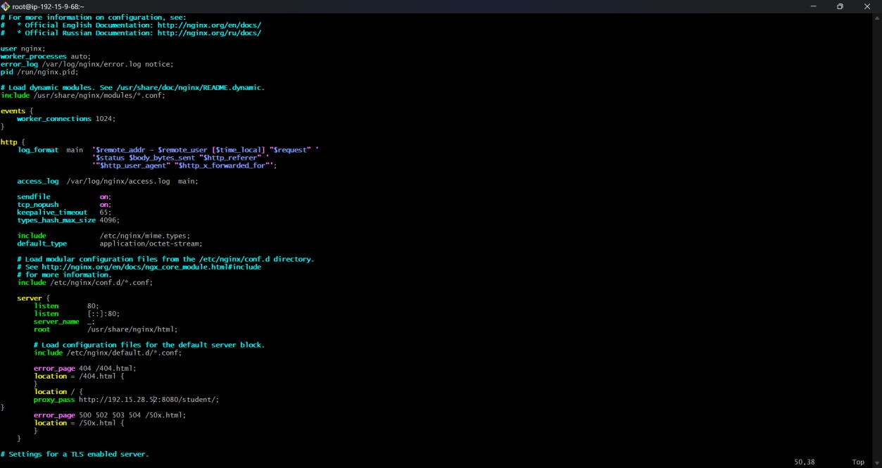

After this all changes restart nginx.

-step 12: After this all changes when we hit public ip of the jump server then The request is forword towards the application server.





-step 13: Create VPCb and create one subnet

-step 15: create ec2instance in VPC which is a db instance

-step 14: install mariadb105* then start and enable

-step 15: Connet that ec2-instance on the git bash then configure database mysql -h <endpoint> -u <username> -p<password>

$ create database studentapp;

$ use studentapp;

$ create table by using below query

CREATE TABLE if not exists students(student_id INT NOT NULL AUTO_INCREMENT, student_name VARCHAR(100) NOT NULL,

student_addr VARCHAR(100) NOT NULL, student_age VARCHAR(3) NOT NULL, student_qual VARCHAR(20) NOT NULL, student_percent VARCHAR(10) NOT NULL, student_year_passed VARCHAR(10) NOT NULL, PRIMARY KEY (student_id)

);

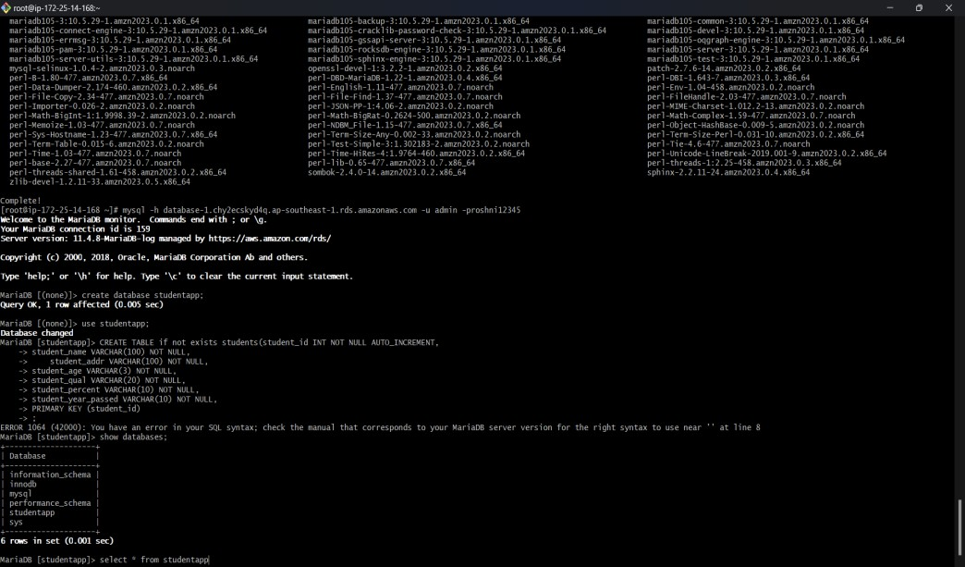

-step 16: After that in the application server inside the tomcat folder inside lib Add connector file

curl -O <https://s3-us-west-2.amazonaws.com/studentapi-cit/mysql-connector.jar>

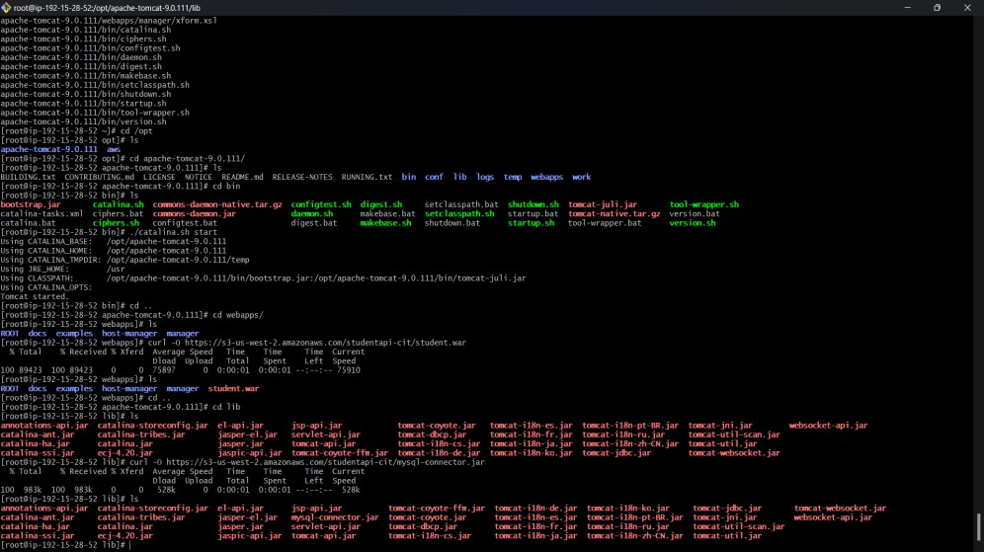

then inside conf folder opend file contex.xml and add endpoint username and password of the DB instance.

vim contex.xml

username="admin" password="roshni12345" endpoint.

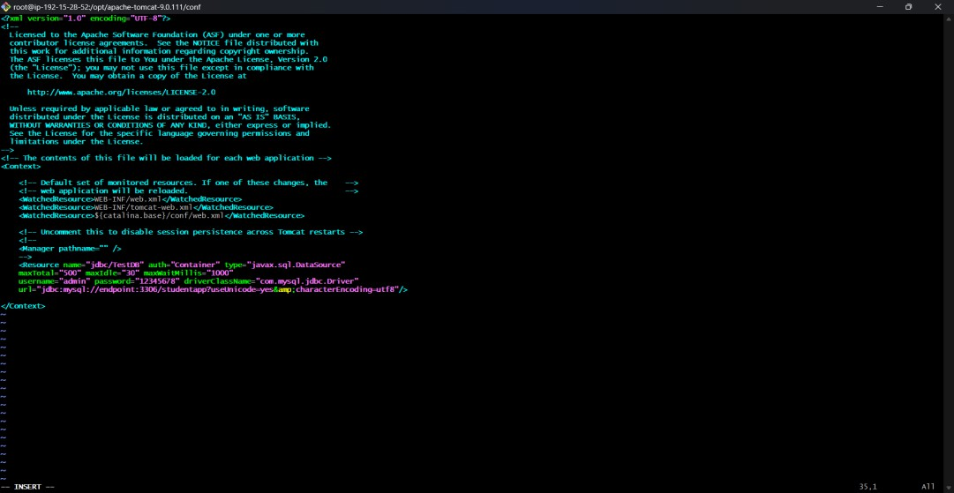

step 17: Create a peering connection in the VPCa is a requester VPC and VPCb is the acceptor. 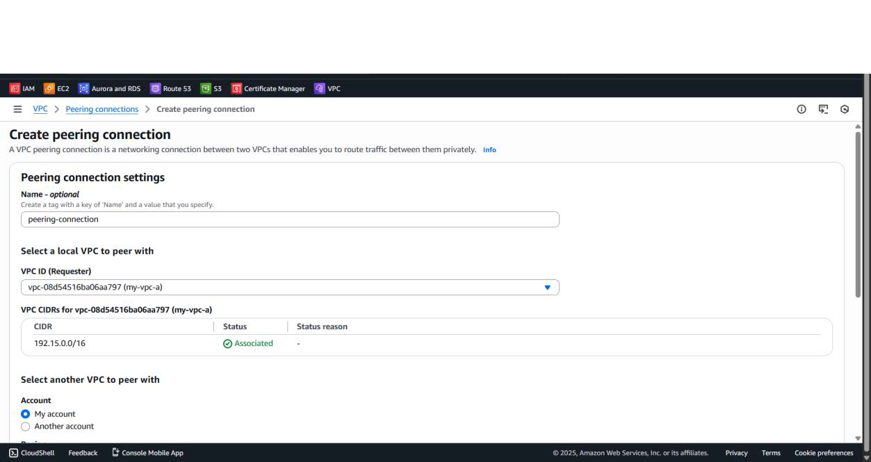

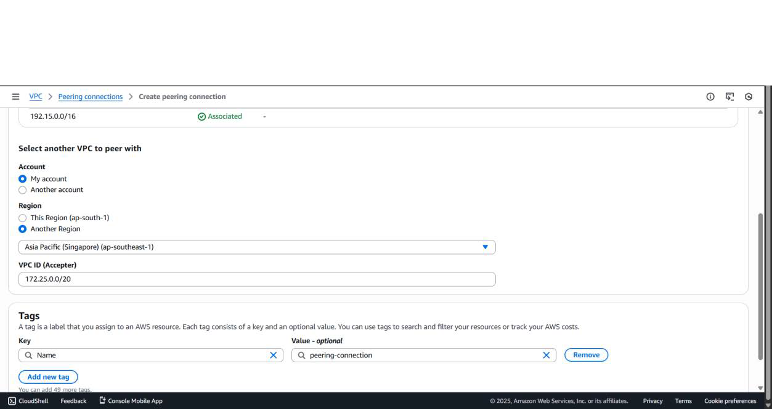

-step 18: create route table in the VPCa for VPC peering in the destination mention subnet CIDR of the VPCb subnet and choose peering connection and associate private subnet.

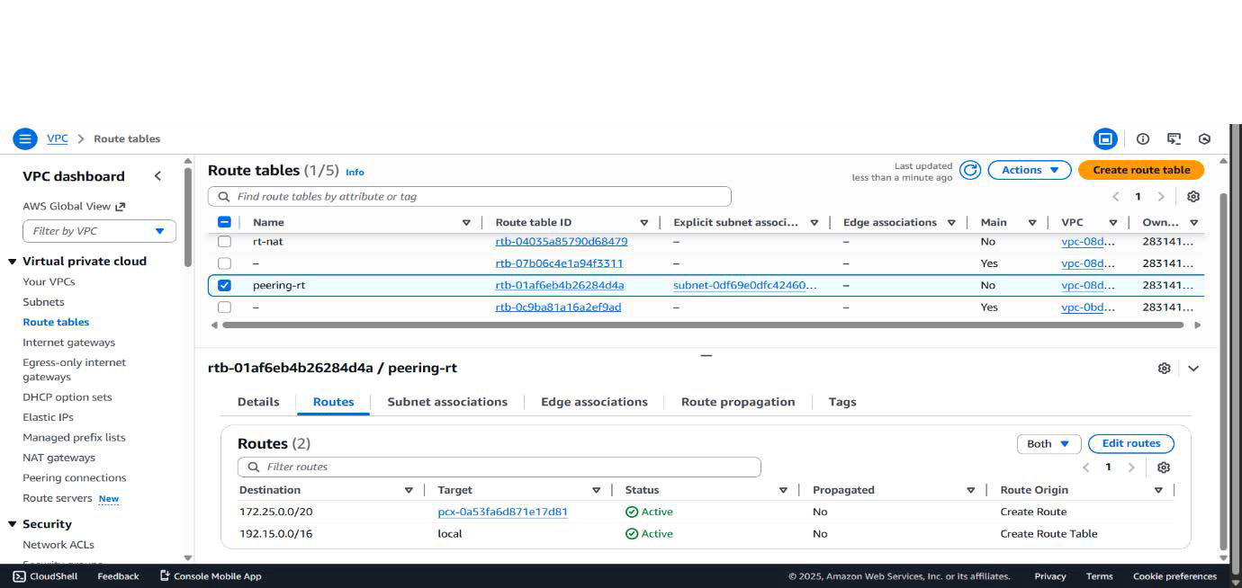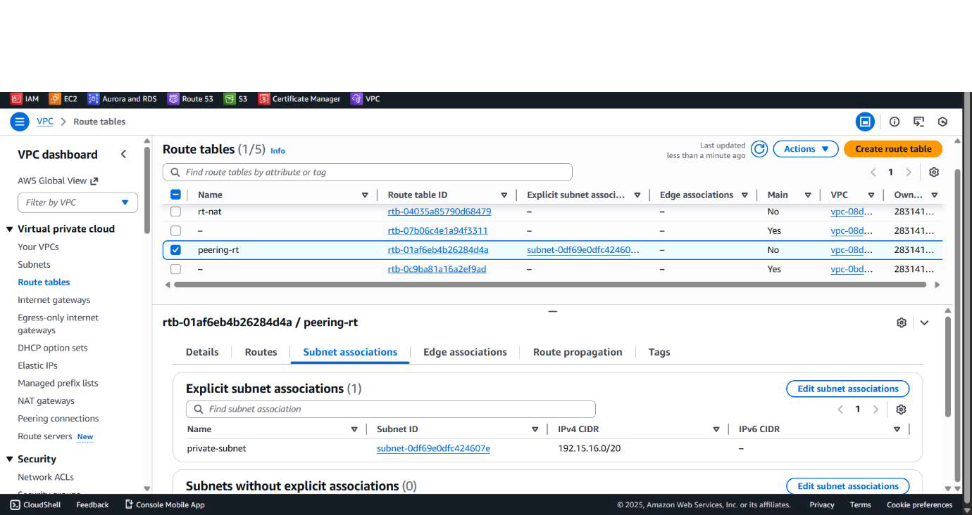

-step 19: in the VPCb accept that request and create route table and in the destination mention subnet CIDR of VPCa private subnet and associate subnet of VPCb. Allow All ICMP IPV4 In the security group of VPCa And VPCb. It helps to Communication and ping.

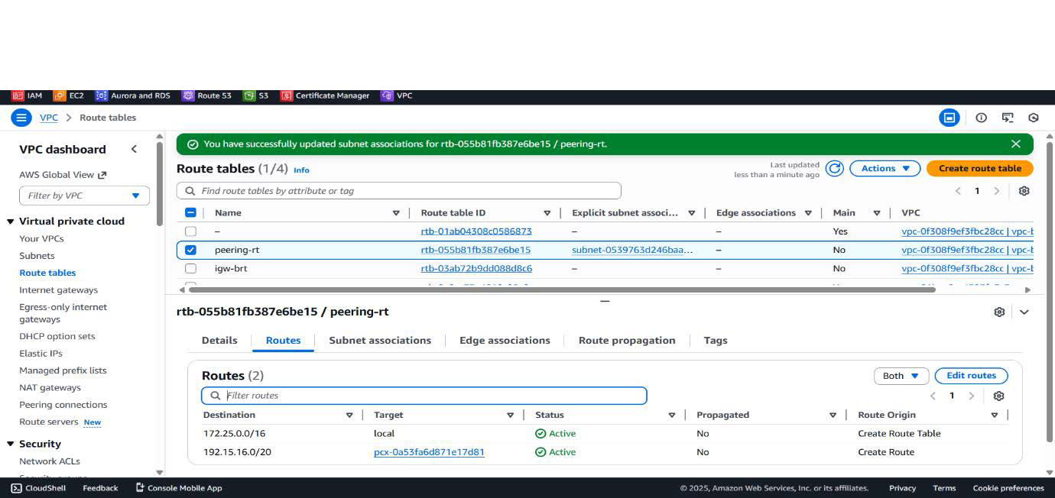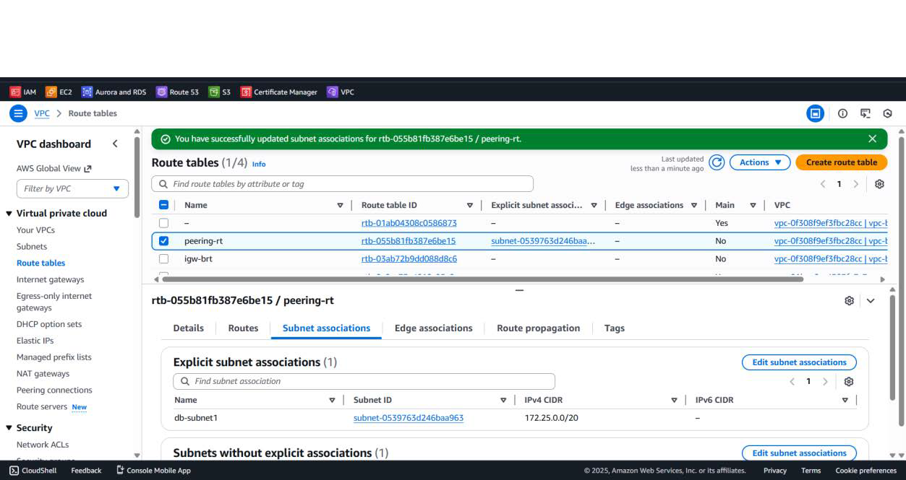

-Step 20: see result all register student are stored in the database.

